Name and Surname: Tshiamo Pitso

Student number: ST10317843

Module: Introduction to Mobile Application Development

Module code: IMAD5112

Lecturer: Mr. Steven Ndaye

IMAD EXAM REWRITE

Purpose and Explanation of the app.

Budget Buddy is a handy mobile app that serves as a personal financial assistant, designed to simplify daily expense tracking and budget management for students. With its user-friendly interface and engaging functionality, Budget Buddy makes it a breeze for students to stay on top of their spending habits and avoid breaking the bank. Whether you're a college student keeping tabs on your daily coffee fix, or a high school student budgeting for that must-have pair of shoes, Budget Buddy has you covered. With its easy-to-use features, you can keep track of your expenses in real-time and even get a daily summary of your spending.

The Screens:

Navigation between Screens:

Splash Screen navigates to the Main Screen automatically after a delay.

Main Screen contains a button that navigates to the Detailed View screen when clicked.

Detailed View screen contains a button that navigates back to the Main Screen.

Conclusion:

This app implements parallel arrays, loops, and functions to track and display daily spending. It features a Splash Screen, Main Screen with an expense summary, and a Detailed View Screen showing the breakdown of daily expenses. Additionally, it calculates the highest spending day and average daily spending. The user can navigate smoothly between screens via buttons.

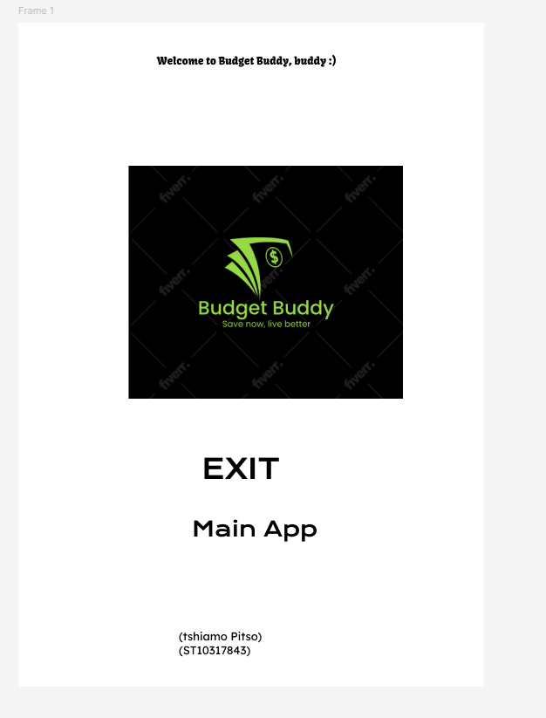

The Splash Screen(Design)

The Main Screen(Design)

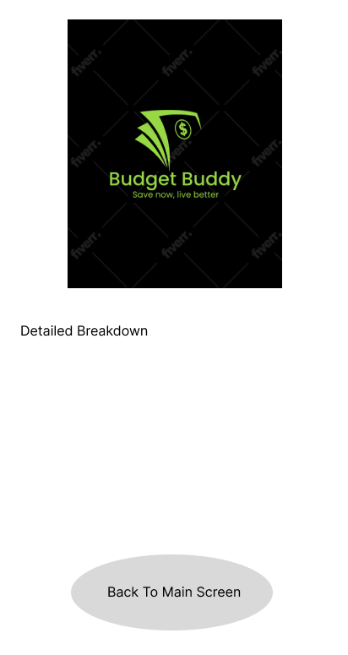

The Detailed Expenses Screen. (Design)

A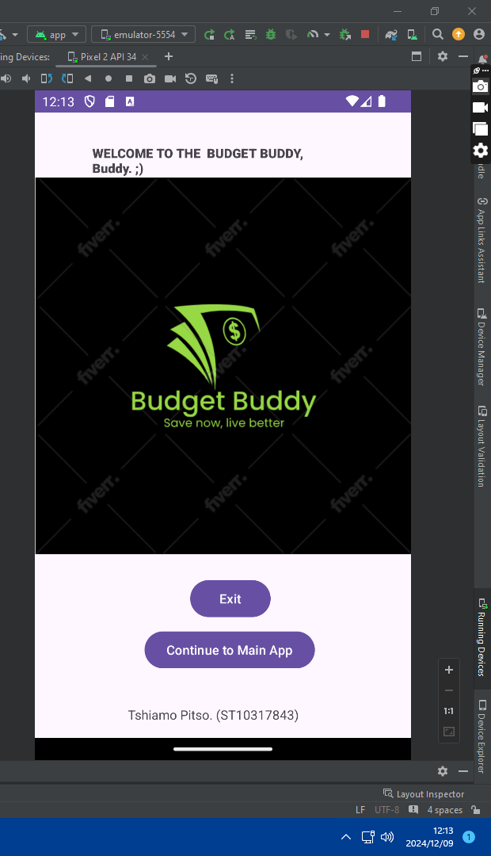

The coded Screen

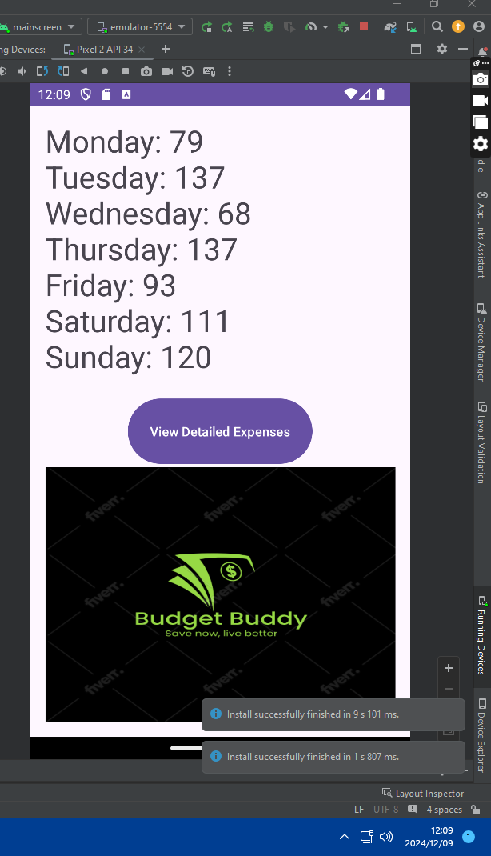

Coded Screen for Detailed screen

